**DAILY ONLINE ACTIVITIES SUMMARY**

|  |  |  |  |  |  |  |  |  |
| --- | --- | --- | --- | --- | --- | --- | --- | --- |
| **Date:** | **09/07/2020** | | | | | **Name:** | **AKASH S** | |
| **Sem & Sec** | **4TH&A** | | | | | **USN:** | **4AL18CS004** | |
| **Online Test Summary** | | | | | | | | |
| **Subject** | | **----** | | | | | | |
| **Max. Marks** | | **--** | | **Score** | | | **--** | |
| **Certification Course Summary** | | | | | | | | |
| **Course** | **INTRODUCTION TO R** | | | | | | | |
| **Certificate Provider** | | | **GREAT LEARNING** | | **Duration** | | | **3 HOURS** |
| **Coding Challenges** | | | | | | | | |
| **Problem Statement 1:** **---** | | | | | | | | |
| **Status: executed** | | | | | | | | |
| **Uploaded the report in Github** | | | | | **YES** | | | |
| **If yes Repository name** | | | | | <https://github.com/akashacharya786/lockdown-c-coding>  **https://github.com/akashacharya786/lockdown-java-coding** | | | |
| **Uploaded the report in slack** | | | | | **YES** | | | |

**Online Test Summary: Not conducted**

**Online Certification course:**

Name of the course :introduction to R

Duration: 3 hours

Certificate provider: great learning

Snap shot:

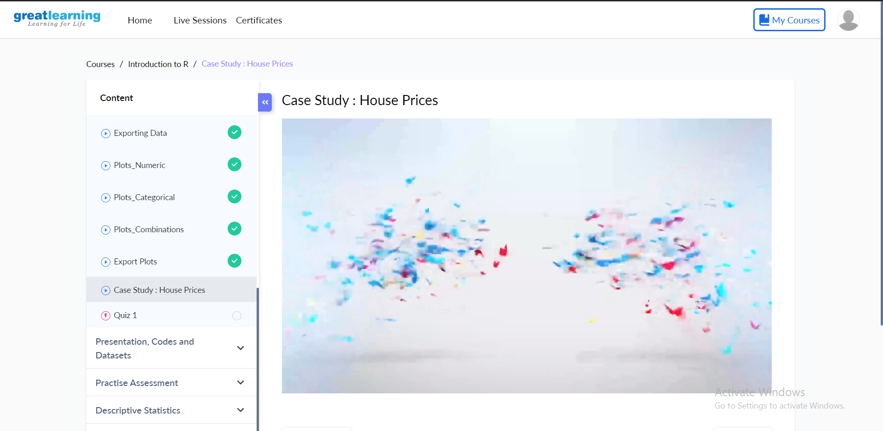

Today I have succesfully completed all the chapters of the above course.

Online Coding summary:--